Task
Your task is to write a film review for ‘The Edge of Love’.
Language
- A review needs to be lively and interesting.
- You could use some specific language techniques to hold the reader’s attention, for example, tripling, alliteration, rhetorical questions and facts.
- You will need to directly address the reader.
- Make sure that you use evidence from the film.
- Make sure that you express your personal opinion clearly.
- Your language can be more informal due to your target audience.
PALL
Purpose: What are you trying to do?
Audience: Who is your review aimed at?
Language: What language features are you going to use?
Layout: How are you going to set your review out?

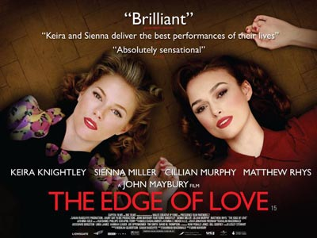
Content
You must cover the following:
- Title;
- Certificate;
- Stars;
- An overview of the plot;
- Characters;
- Best and worst bits;
- Recommendations.
Success Criteria
You must:
- Follow the guidance on content.
- Follow the above guidance on language.
- Write clearly and coherently.
- Vary your vocabulary.
- Vary your sentence lengths.
- Use a range of punctuation accurately.
- Use language which is appropriate for your task and your audience.
- Use paragraphs to structure your ideas.
Two Stars and a Wish


